**Name of the College: NIIT R.G.P.G College Meerut **

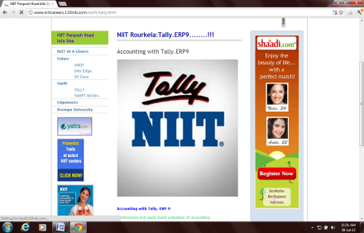 Student Name:________________________________Reg no:________________________

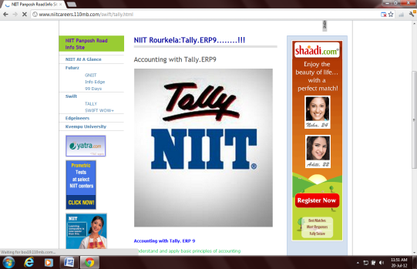 Class:______________Date:_________________Time:30 Min Max Marks: 100 Marks **Set-2**

**QUALIFYING EXAM OF TALLY**

|  |  |  |  |  |  |  |  |
| --- | --- | --- | --- | --- | --- | --- | --- |
| SN | QUESTION_STATEMENT | ANS_A | ANS_B | ANS_C | ANS_D | ANS_E | Ans |
| 1 | What is the shortcut key to delete a Budget ? | Alt+B | Alt+D | Alt+C | None |  | B |
| 2 | Is it possible to assign Multiple Price levels for Invoicing ? | Yes | No |  |  |  | A |
| 3 | Company features are applicable with the current company only | True | FALSE |  |  |  | A |
| 4 | To pass the Receipt Note return choose | Rejection In | Rejection Out | Credit Note | Debit Note | None of these | B |
| 5 | """Proprietor goods taken over for personal use "" It should be passed through " | a) Payment | b) journal | c) receipts | d) None of the above |  | B |
| 6 | To display net balances of the account group / subgroup instead of debit and credit balances in separate columns we will activate- | Net Debit / Credit Balances for Reporting | Group behaves like a Sub-Ledger | Used for Calculation | None of these |  | A |
| 7 | Debit Note vouchers can be used for | Sales Return | Sales Order | Purchase Return | Rejection Out |  | C |
| 8 | To maintain stock categories one should mark | Activate interest calculation | Invoice for capital Goods | More than one cost categories | Maintain Stock categories | All of the above | D |
| 9 | which button is used for payroll auto fill | a) ctrl + F7 | b) Alt + F4 | c) ctrl + v | d) Alt + O |  | A |
| 10 | How to display the payslip report | a) GOT > Display > Day Book | b) GOT > Display > Payslip | c) GOT > Display > Payroll Reports > Stement of payroll>Payslip | d) Either (a) or (b) |  | c |
| 11 | To save a Voucher from any position press | F4 | Ctrl + U | Ctrl + A | Ctrl + V |  | C |
| 12 | In general the Financial year from is stareted from | 1st April of any year | 31st March of any year | All of them are true | None of these |  | a |
| 13 | Tally Vault password is used | To set user name & password for the company but it will not show the name of the company in Select Company List | To set user name & password for the company but it will show the name of the company in Select Company List | To lock the period of the Company | To set the password for the company but it will not view the name of the company in Select Company List |  | d |
| 14 | To maintain Godown with Inventory turn on the option | Maintain Locations in F11 | Use Godowns in F12 | Maintain Multiple Godowns in F11 | Use Multiple Locations in F12 |  | C |
| 15 | Is it possible to see the vouchers which have been already Reconciled ? | True | False |  |  |  | A |
| 16 | The shortcut of changing period is invoked by pressing | F2 | ALT + F2 | CTRL + F2 | F1 |  | b |
| 17 | Bill reference can be of | 4 types | 5 types | 9types | 7types | All of the above | A |
| 18 | Split Company and Group Company are not the same | Yes | No |  |  |  | a |
| 19 | Shortcut for Budget Variance | Ctlr + N | Alt + 2 | Alt + V | Ctrl + S | Alt + B | E |
| 20 | input cr on capital goods falls under | a) Current liabilities | b) Duties and taxes | c) Loan liabilities | d) All of the above |  | b |
| 21 | date field in voucher creation mode can be skipped | TRUE | FALSE |  |  |  | a |
| 22 | We can give opening balances to the ledger accounts at the time of | Ledger Creation | Group Creation | Voucher Entry | None of these |  | A |
| 23 | Machine purchased for production of goods the VAT rate will be | 1percent | 4percent | 20percent | 12.5percent | nil | B |
| 24 | To enter voucher number manually in tally we should modify | configuration window | feature window | voucher type | voucher class |  | C |
| 25 | Advance salary falls under | a) Current Assets | b) Duties and taxes | c) Loans & advances( assets) | d) a and c |  | d |
| 26 | Formal name of any unit should be different from Symbol name | True | False |  |  |  | A |
| 27 | If a company is actually established on 1st September 2002 the Financial Year from will be | 1st September 2002 | 1st October 2002 | 1st April 2002 | 1st April 2003 | None of these | C |
| 28 | Default ledgers in tally are | CASH A / C CAPITAL A / C & CLOSING STOCK A / C | CASH A / C & CLOSING STOCK A / C | CASH A / C & PROFIT & LOSS A / C | NO DEFAULT LEDGERS ARE THERE. |  | C |
| 29 | In Journal voucher Cash / Bank entry is possible. | True | False |  |  |  | A |
| 30 | Reorder Level is a ___________ for stock item. | Quality | Cost | Quantity | None of these |  | C |
| 31 | An assessable value is | on which Vat is to be calculated | On which TDS is charged | On which Sales tax is calculated | None of the above | All of the above | A |
| 32 | Tally has extensive internet capabilities | TRUE | FALSE | - | - | - | A |
| 33 | To get detail report format press | Alt + 1 | Alt + F1 | Alt + 2 | Alt + F2 |  | B |
| 34 | """Cash withdrawal for personal use"" the entry should be passed through " | a) Receipt | b) Payment | c) Contra | D) Journal |  | B |
| 35 | BOM Stands for | Base of materials | Bill of materials | Bill of matter | Bill of management |  | B |
| 36 | We can see the daily break-up report in cash book by press | F8 | F6 | F2 | Alt + w |  | B |
| 37 | Allow 0 valued entries in voucher option is set to Yes when we need to pass | Accounting vouchers without any value | Inventory vouchers without any value | Free goods | both a & b |  | D |
| 38 | To activate Price List how many options from F11 should be turned on? | 4 | 3 | 1 | 2 |  | C |
| 39 | To work with Track Additional Cost of Purchase you need | Voucher mode | Invoice mode | Both | None of these |  | A |
| 40 | Working Capital means | Fixed Assets - Current Liabilities | Current Assets - Current Liabilities | Current Liabilitites - Current Assets | None of these |  | B |
| 41 | Document re-numbering is possible in Tally | a) True | b) False |  |  |  | B |
| 42 | Voucher Type option is available in | Account Info | Inventory Info | Not available | In both of A and B |  | D |
| 43 | To delete the Master which key you will use ? | Shift+d | Alt+D | Esc | Alt+c |  | B |
| 44 | To give notes for a particular ledger account one should mark | Allow Advance entries in master in F12 | Allow Contact Details for ledger account in F12 | Allow Notes for Ledger Account in F12 | Add Notes for Ledger Account in F12 | None of the above | D |
| 45 | "What is the No. of ""VAT return form""" | a) Form 16 | b) Form 16A | c) Form 14 | d) Form 60 |  | C |
| 46 | To switch from one inventory report to another inventory report we use | F1 | F10 | F9 | none of these |  | C |
| 47 | At the time of company creation if Accounts Only option has been selected then | we cannot pass purchase / sales transaction | we cannot maintain inventory | we cannot maintain party | A and B | A and C | B |
| 48 | The account subgroup Deposits is under | Current Liability | Current Assets | Fixed Assets | Reserve and Surplus |  | B |
| 49 | VAT is Charged on | Cost price | Sale price | Assessable Value | All of the above | None of the above | C |
| 50 | To convert any voucher to Post Dated press | Alt + P | Ctrl + P | Alt + T | Ctrl + T | None of these | D |